Lab 11 – Data Structures with AI: Implementing Fundamental Structures

Name:V.Prapul Kumar

Roll no:2503A52377

Batch-13
Task Description #1 – Stack Implementation
Task: Use AI to generate a Stack class with push, pop, peek, and is_empty methods.

Prompt:
Complete the following Python Stack class for a beginner data structures lab.

Add the required push(), pop(), peek(), and is_empty() methods. Use a Python list to store the elements and follow the LIFO principle. Handle empty-stack cases properly and include short docstrings for the class and each method. Keep the code simple and beginner-friendly.

Starting code:

class Stack:
pass
Code:
class Stack:
"""A simple stack implementation using a Python list."""

def __init__(self):
"""Initialize an empty stack."""
self.items = []

def push(self, item):
"""Add an item to the top of the stack."""
self.items.append(item)

def pop(self):
"""Remove and return the top item."""
if self.is_empty():
return None
return self.items.pop()

def peek(self):
"""Return the top item without removing it."""
if self.is_empty():
return None
return self.items[-1]

def is_empty(self):
"""Check whether the stack is empty."""
return len(self.items) == 0

# Testing the Stack
stack = Stack()

stack.push(10)
stack.push(20)
stack.push(30)

print("Stack:", stack.items)
print("Top element:", stack.peek())
print("Removed:", stack.pop())
print("Stack after pop:", stack.items)
print("Is empty?", stack.is_empty())

Output:
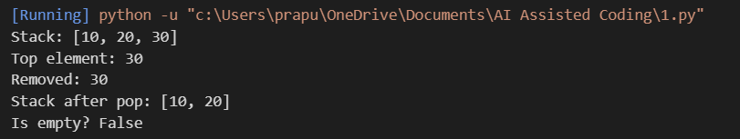

Justification:
The Stack was implemented successfully using a Python list. The required push(), pop(), peek(), and is_empty() methods were added with appropriate docstrings. The implementation was tested with sample values and correctly followed the LIFO (Last In, First Out) principle.
Task Description #2 – Queue Implementation
Task: Use AI to implement a Queue using Python lists.
Sample Input Code:
class Queue:

Prompt:
Complete this Python Queue class with enqueue(), dequeue(), peek(), and size() methods using a list. Follow FIFO, handle an empty queue, and add short docstrings.

Code:
class Queue:
"""A simple queue implementation using a Python list."""

def __init__(self):
"""Initialize an empty queue."""
self.items = []

def enqueue(self, item):
"""Add an item to the rear of the queue."""
self.items.append(item)

def dequeue(self):
"""Remove and return the front item."""
if self.size() == 0:
return None
return self.items.pop(0)

def peek(self):
"""Return the front item without removing it."""
if self.size() == 0:
return None
return self.items[0]

def size(self):
"""Return the number of items in the queue."""
return len(self.items)

# Testing the Queue
queue = Queue()

queue.enqueue(15)
queue.enqueue(25)
queue.enqueue(35)

print("Queue:", queue.items)
print("Front element:", queue.peek())
print("Removed:", queue.dequeue())
print("Queue after dequeue:", queue.items)

print("Queue size:", queue.size())
Output:
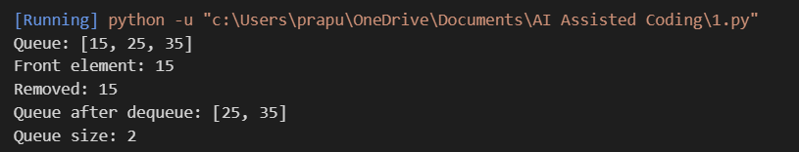

Justification:
The Queue was implemented successfully using a Python list. The required enqueue(), dequeue(), peek(), and size() methods were included with docstrings. The implementation was tested with sample values and correctly follows the FIFO (First In, First Out) principle.
Task Description #3 – Linked List
Task: Use AI to generate a Singly Linked List with insert and display methods.

Prompt:
Complete these Python Node and LinkedList classes with insert() and display() methods. Create a singly linked list, add short docstrings, and keep the code beginner-friendly.

Code:
class Node:
"""Represents a node in the singly linked list."""

def __init__(self, value):
"""Initialize a node with a value."""
self.data = value
self.next = None

class LinkedList:
"""A simple singly linked list."""

def __init__(self):
"""Initialize an empty linked list."""
self.head = None

def insert(self, value):
"""Insert a new node at the end of the list."""
new_node = Node(value)

if self.head is None:
self.head = new_node
return

current = self.head

while current.next is not None:
current = current.next

current.next = new_node

def display(self):
"""Display all elements in the linked list."""
current = self.head

while current is not None:
print(current.data, end=" -> ")
current = current.next

print("None")

# Testing the Linked List
linked_list = LinkedList()

linked_list.insert(15)
linked_list.insert(25)
linked_list.insert(35)

print("Linked List:")

linked_list.display()
Output:
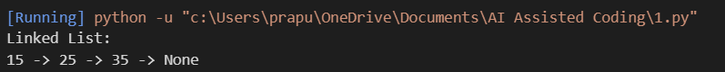

Justification:
The singly linked list was implemented successfully using Node and LinkedList classes. The insert() method adds new nodes to the list, while the display() method shows all the elements in sequence. The implementation was tested with sample values and worked correctly.
Task Description #4 – Binary Search Tree (BST)
Task: Use AI to create a BST with insert and in-order traversal methods.

Prompt:
Complete this Python BST class with recursive insert() and in_order() traversal methods. Add short docstrings and keep it beginner-friendly.

Code:
class Node:
"""Represents a node in a Binary Search Tree."""

def __init__(self, value):
"""Initialize a BST node."""
self.data = value
self.left = None
self.right = None

class BST:
"""A simple Binary Search Tree."""

def __init__(self):
"""Initialize an empty BST."""
self.root = None

def insert(self, value):
"""Insert a value into the BST."""
self.root = self._insert(self.root, value)

def _insert(self, node, value):
"""Recursively place a value in the correct position."""
if node is None:
return Node(value)

if value < node.data:
node.left = self._insert(node.left, value)
elif value > node.data:
node.right = self._insert(node.right, value)

return node

def in_order(self):
"""Display the BST using in-order traversal."""
self._traverse(self.root)
print()

def _traverse(self, node):
"""Visit the left subtree, node, and right subtree."""
if node is not None:
self._traverse(node.left)
print(node.data, end=" ")
self._traverse(node.right)

# Testing the BST
tree = BST()

values = [45, 25, 65, 15, 35, 55, 75]

for value in values:
tree.insert(value)

print("In-order traversal:")

tree.in_order()
Output:

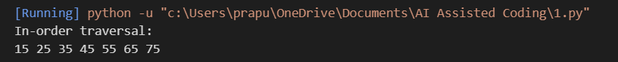

Justification:
The Binary Search Tree was implemented successfully using recursive insertion and in-order traversal. The test values were inserted into the BST and the in-order traversal displayed them in sorted order.
Task Description #5 – Priority Queue
Task: Use AI to implement a priority queue using Python’s heapq module.

Prompt:
Complete this Python PriorityQueue class using heapq. Add enqueue(), dequeue(), and display() methods, handle an empty queue, and add short docstrings.
Code:
import heapq

class PriorityQueue:
"""A simple priority queue using heapq."""

def __init__(self):
"""Initialize an empty priority queue."""
self.queue = []

def enqueue(self, item, priority):
"""Add an item with its priority."""
heapq.heappush(self.queue, (-priority, item))

def dequeue(self):
"""Remove and return the highest-priority item."""
if len(self.queue) == 0:
return None

priority, item = heapq.heappop(self.queue)
return item

def display(self):
"""Display the priority queue."""
print("Priority Queue:", self.queue)

# Testing the Priority Queue
pq = PriorityQueue()

pq.enqueue("Email", 2)
pq.enqueue("Project", 5)
pq.enqueue("Assignment", 3)

pq.display()

print("Removed:", pq.dequeue())
print("Removed:", pq.dequeue())

print("Removed:", pq.dequeue())
Output:
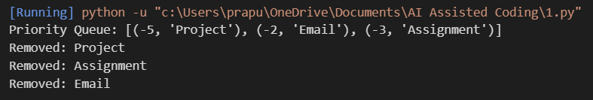

Justification:
The Priority Queue was implemented using Python's heapq module. Items were assigned priorities and removed according to their priority, with the highest-priority item being processed first.
Task Description #6 – Deque

Task: Use AI to implement a double-ended queue using collections.deque

Prompt:
Complete this Python DequeDS class using collections.deque. Add methods to insert and remove items from both ends, handle empty cases, and include short docstrings.

Code:
from collections import deque

class DequeDS:
"""A double-ended queue using collections.deque."""

def __init__(self):
"""Initialize an empty deque."""
self.items = deque()

def insert_front(self, value):
"""Insert a value at the front."""
self.items.appendleft(value)

def insert_rear(self, value):
"""Insert a value at the rear."""
self.items.append(value)

def remove_front(self):
"""Remove and return the front value."""
if len(self.items) == 0:
return None
return self.items.popleft()

def remove_rear(self):
"""Remove and return the rear value."""
if len(self.items) == 0:
return None
return self.items.pop()

def display(self):
"""Display the elements of the deque."""
print("Deque:", list(self.items))

# Testing the Deque
d = DequeDS()

d.insert_front(15)
d.insert_rear(25)
d.insert_front(5)

d.display()

print("Removed from front:", d.remove_front())
print("Removed from rear:", d.remove_rear())

d.display()
Output:
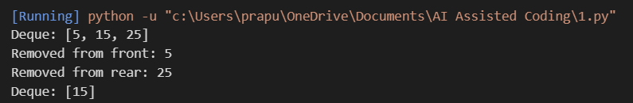

Justification:
The Deque was implemented using Python's collections.deque. The program supports insertion and removal from both the front and rear and was tested successfully with sample operations.
Task Description #7 Real-Time Application Challenge – Choose the Right Data Structure
Scenario:
Your college wants to develop a Campus Resource Management System that handles:
- Student Attendance Tracking – Daily log of students entering/exiting the campus.
- Event Registration System – Manage participants in events with quick search and removal.
- Library Book Borrowing – Keep track of available books and their due dates.
- Bus Scheduling System – Maintain bus routes and stop connections.
- Cafeteria Order Queue – Serve students in the order they arrive.
Student Task:
- For each feature, select the most appropriate data structure from the list below:
  - Stack
  - Queue
  - Priority Queue
  - Linked List
  - Binary Search Tree (BST)
  - Graph
  - Hash Table
  - Deque

Prompt:
Create a beginner-friendly Python CafeteriaOrderQueue using a list. Add methods to place an order, serve the first order, and display pending orders. Handle an empty queue and include short docstrings and comments.

Code:
class CafeteriaOrderQueue:
"""Queue for managing cafeteria orders."""

def __init__(self):
"""Initialize an empty order queue."""
self.orders = []

def add_order(self, student, food):
"""Add a student's food order."""
order = f"{student} - {food}"
self.orders.append(order)
print("Order added:", order)

def serve_order(self):
"""Serve the first order in the queue."""
if len(self.orders) == 0:
print("No orders to serve.")
return

order = self.orders.pop(0)
print("Order served:", order)

def display_orders(self):
"""Display all pending orders."""
if len(self.orders) == 0:
print("No pending orders.")
return

print("Pending Orders:")
for order in self.orders:
print(order)

# Testing the Cafeteria Order Queue
cafeteria = CafeteriaOrderQueue()

cafeteria.add_order("Kiran", "Burger")
cafeteria.add_order("Ananya", "Pizza")
cafeteria.add_order("Rohan", "Sandwich")

print()
cafeteria.display_orders()

print()
cafeteria.serve_order()

print()

cafeteria.display_orders()
Output:

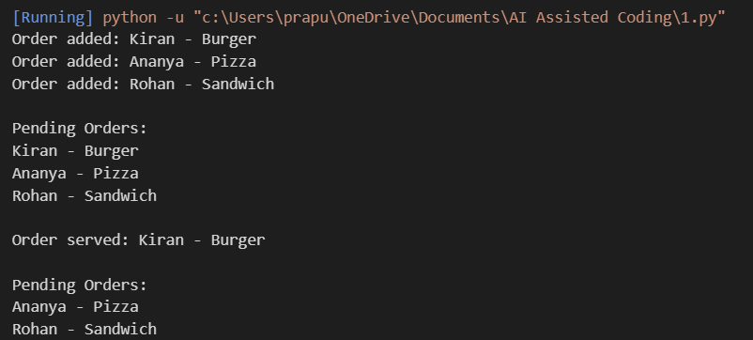

Justification:
A Queue was selected for cafeteria orders because students should be served in the same order in which they place their orders. The feature was implemented successfully using a Python list and tested with multiple sample orders.
Task Description #8: Smart E-Commerce Platform – Data Structure Challenge
An e-commerce company wants to build a Smart Online Shopping System with:
- Shopping Cart Management – Add and remove products dynamically.
- Order Processing System – Orders processed in the order they are placed.
- Top-Selling Products Tracker – Products ranked by sales count.
- Product Search Engine – Fast lookup of products using product ID.
- Delivery Route Planning – Connect warehouses and delivery locations.
Student Task:
- For each feature, select the most appropriate data structure from the list below:
  - Stack
  - Queue
  - Priority Queue
  - Linked List
  - Binary Search Tree (BST)

Deque
Prompt:
Create a beginner-friendly Python OrderQueue using a list. Add methods to add an order, process the first order, and display pending orders. Follow FIFO, handle an empty queue, and include short docstrings.
Code:
class OrderQueue:
"""Queue for processing online shopping orders."""

def __init__(self):
"""Initialize an empty order queue."""
self.orders = []

def add_order(self, order_id, customer):
"""Add a new customer order."""
order = f"{order_id} - {customer}"
self.orders.append(order)
print("Order added:", order)

def process_order(self):
"""Process the oldest order."""
if len(self.orders) == 0:
print("No orders to process.")
return

order = self.orders.pop(0)
print("Order processed:", order)

def display_orders(self):
"""Display all waiting orders."""
if len(self.orders) == 0:
print("No pending orders.")
return

print("Pending Orders:")
for order in self.orders:
print(order)

# Testing the Order Queue
orders = OrderQueue()

orders.add_order("ORD101", "Kiran")
orders.add_order("ORD102", "Ananya")
orders.add_order("ORD103", "Rohan")

print()
orders.display_orders()

print()
orders.process_order()

print()

orders.display_orders()
Output:

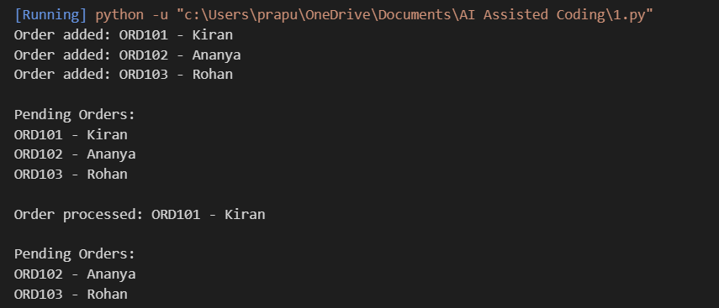

Justification:
A Queue was selected for the order processing system because orders must be processed in the same order in which they are received. The program was implemented using a Python list and successfully demonstrated FIFO order processing.

